Julie Bach & Kwasi Gyamfi Asante
Professor Disha Shende
DSDA 310
Nov 13th, 2025

FINAL REPORT

GreenFuture BioChem is a global manufacturer of bio-based specialty chemicals with five core markets across Automotive Solutions, Consumer & Home Care, Industrial Lubricants, Packaging Materials, and Specialty Polymers, encompassing 50 brand families and over 750 SKUs. This analysis combines four datasets—Sales Pipeline, Manufacturing Production, Supply Chain Procurement, and R&D Pipeline—to provide a holistic view of the company’s profitability and sustainability performance and identify areas for improvement.
Objective
To assess how the company can improve profitability while reinforcing its sustainability mission by:
- Evaluating financial and sales performance across categories and time periods (YTD 2025 focus).
- Analyzing manufacturing cost efficiency and identifying production bottlenecks.
- Examining supply chain emissions and procurement trade-offs.
- Recommending short- and long-term strategies to align profitability with environmental goals.

OVERALL PERFORMANCE
GreenFuture Biochem performed solidly from January to October 2025, generating $7.13 billion in revenue, $1.12 billion in profit, and an overall profit margin of 15.7%. Despite a huge negative profit early in the year, largely due to limited sales opportunities, performance recovered quickly and peaked in October with approximately $1.3 billion in revenue and a 52% margin, driven by an improved win rate (33%) and higher-value sales opportunities.
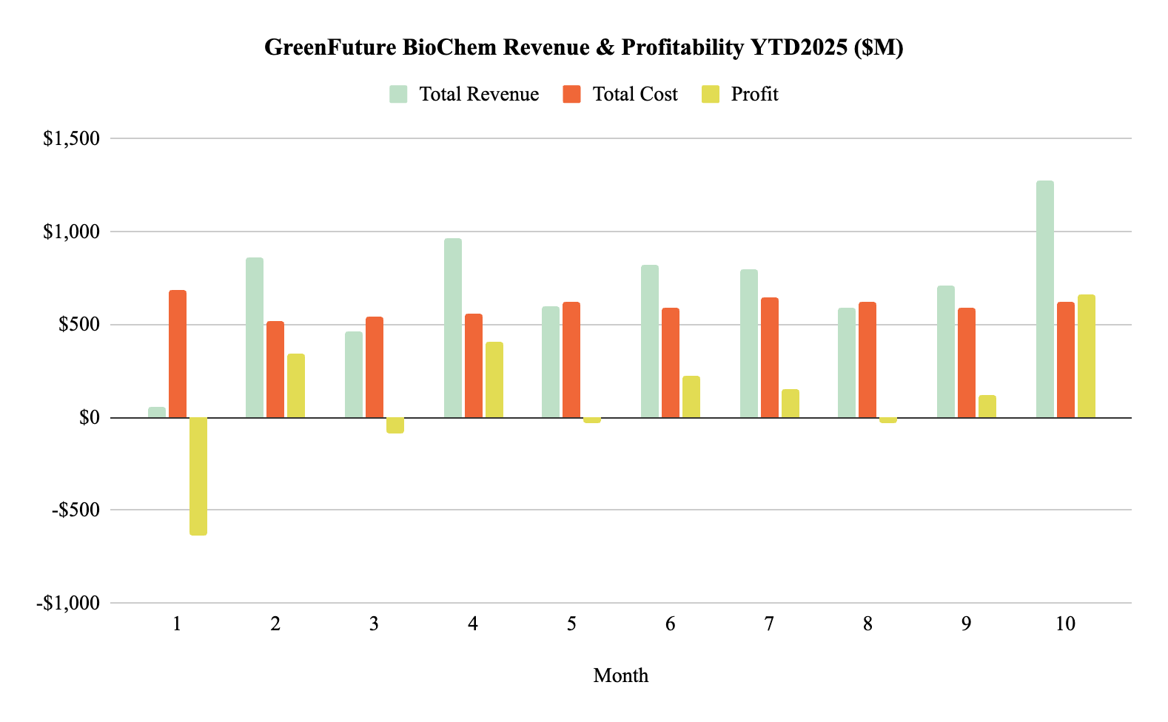
Figure 1. Revenue and Profitability (YTD2025)
1. Sales & Category Insights
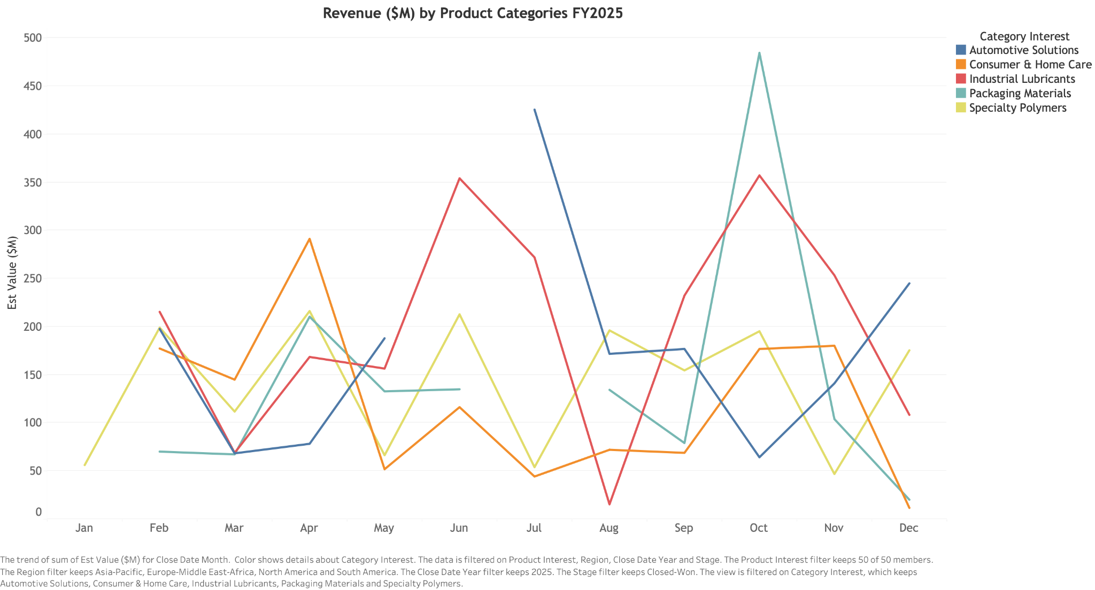
Figure 2. Revenue ($M) by Product Categories (YTD2025)
Although total company performance is strong, category-level performance remains uneven, revealing
two distinct patterns (Figure 2):
- Stable and medium-growth segments: Consumer & Home Care and Specialty Polymers maintained consistent YTD 2025 sales but limited expansion.
- High-volume but volatile segments: Industrial Lubricants, Automotive Solutions, and Packaging Materials delivered strong closed-won deals but fluctuated sharply month to month.
Among these, Industrial Lubricants emerged as the highest revenue driver, contributing roughly 27% of total YTD 2025 revenue and maintaining possibly strong profitability supported by moderated manufacturing cost per MT (Figure 3). Specialty Polymers and Automotive Solutions followed closely, accounting for around 20% and 19% of YTD 2025 revenue, respectively.

However, Consumer & Home Care—despite having the highest forecasted revenue by 2028 (~$17M)—recorded the lowest YTD win rate (~17%) and sales (~1.2M), suggesting weak sales positioning. Specialty Polymers, with the highest win rate (~24%) and strong future revenue growth (~$14M by 2028), remains constrained in profitability by high manufacturing costs per MT (Figure 3).
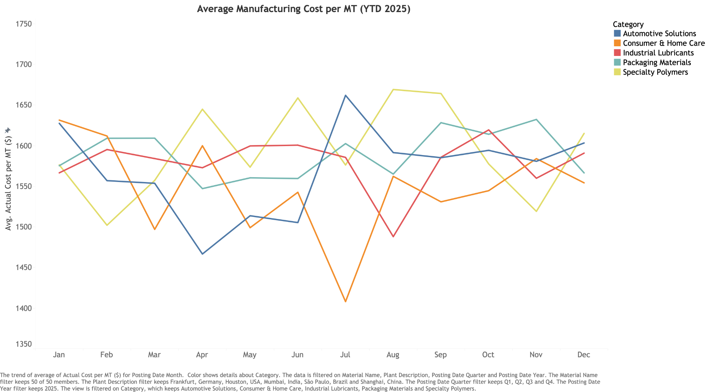
Figure 3. Average Manufacturing Cost per MT by Product Categories (YTD2025)

2. Research & Development
R&D efforts currently concentrate on Industrial Lubricants (69 projects) and Consumer & Home Care (65 projects) between 2025 and 2030. However, this focus does not fully align with sales potential. For instance, Automotive Solutions, which represents 20% of YTD 2025 sales and has the second-highest forecasted revenue (~$16.3M), accounts for the fewest innovation projects at 55. As Specialty Polymers shows strong market promise yet faces high product costs, reallocating a portion of R&D investment toward this category could reduce costs and increase margins. Overall, while high-performing categories deserved sustained focus, innovation investment should be rebalanced toward promising segments.
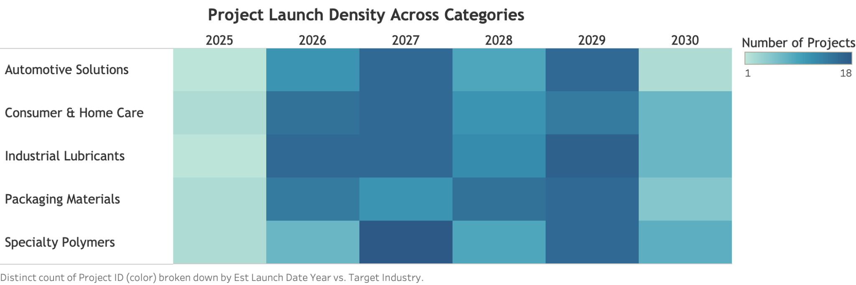
Figure 3. Project Launch Density (2025-2030)

3. Supply Chain & Manufacturing
From a sustainability perspective, GreenFuture’s sourcing decisions demonstrate a clear trade-off between cost efficiency and environmental impact (Figure 4):
- High-emission but low-cost materials: Corn Starch, Cassava Starch, Algae Oil
- Low-emission but higher-cost materials: Wood Pulp, Soy Protein Extract, and Sugarcane Fibre.
Procurement is heavily concentrated in Brazil (Wood pulp, Algae Oil), Malaysia (Corn Starch, Soy Protein Extract), India (Cassava Starch, Sugarcane Fiber), and Indonesia (Palm Oil), potentially increasing logistics-related emissions if transported to different plants.

Top 2 Suppliers (based on total order quantity) by Material
Algae Oil | GreenFibre BV, PalmEco Corp | Soy Protein Extract | PalmEco Corp, GreenFibre BV
Cassava Starch | AgroSource Int., SustainSource Inc. | Sugarcane Fiber | GreenFibre BV, EcoMaterials Co.
Corn Starch | BioFeedstock Ltd., GreenFibre BV | Wood Pulp | PalmEco Corp, SustainSource Inc.
Palm Oil Derivative | AgroSource Intl., NaturInput GmbH
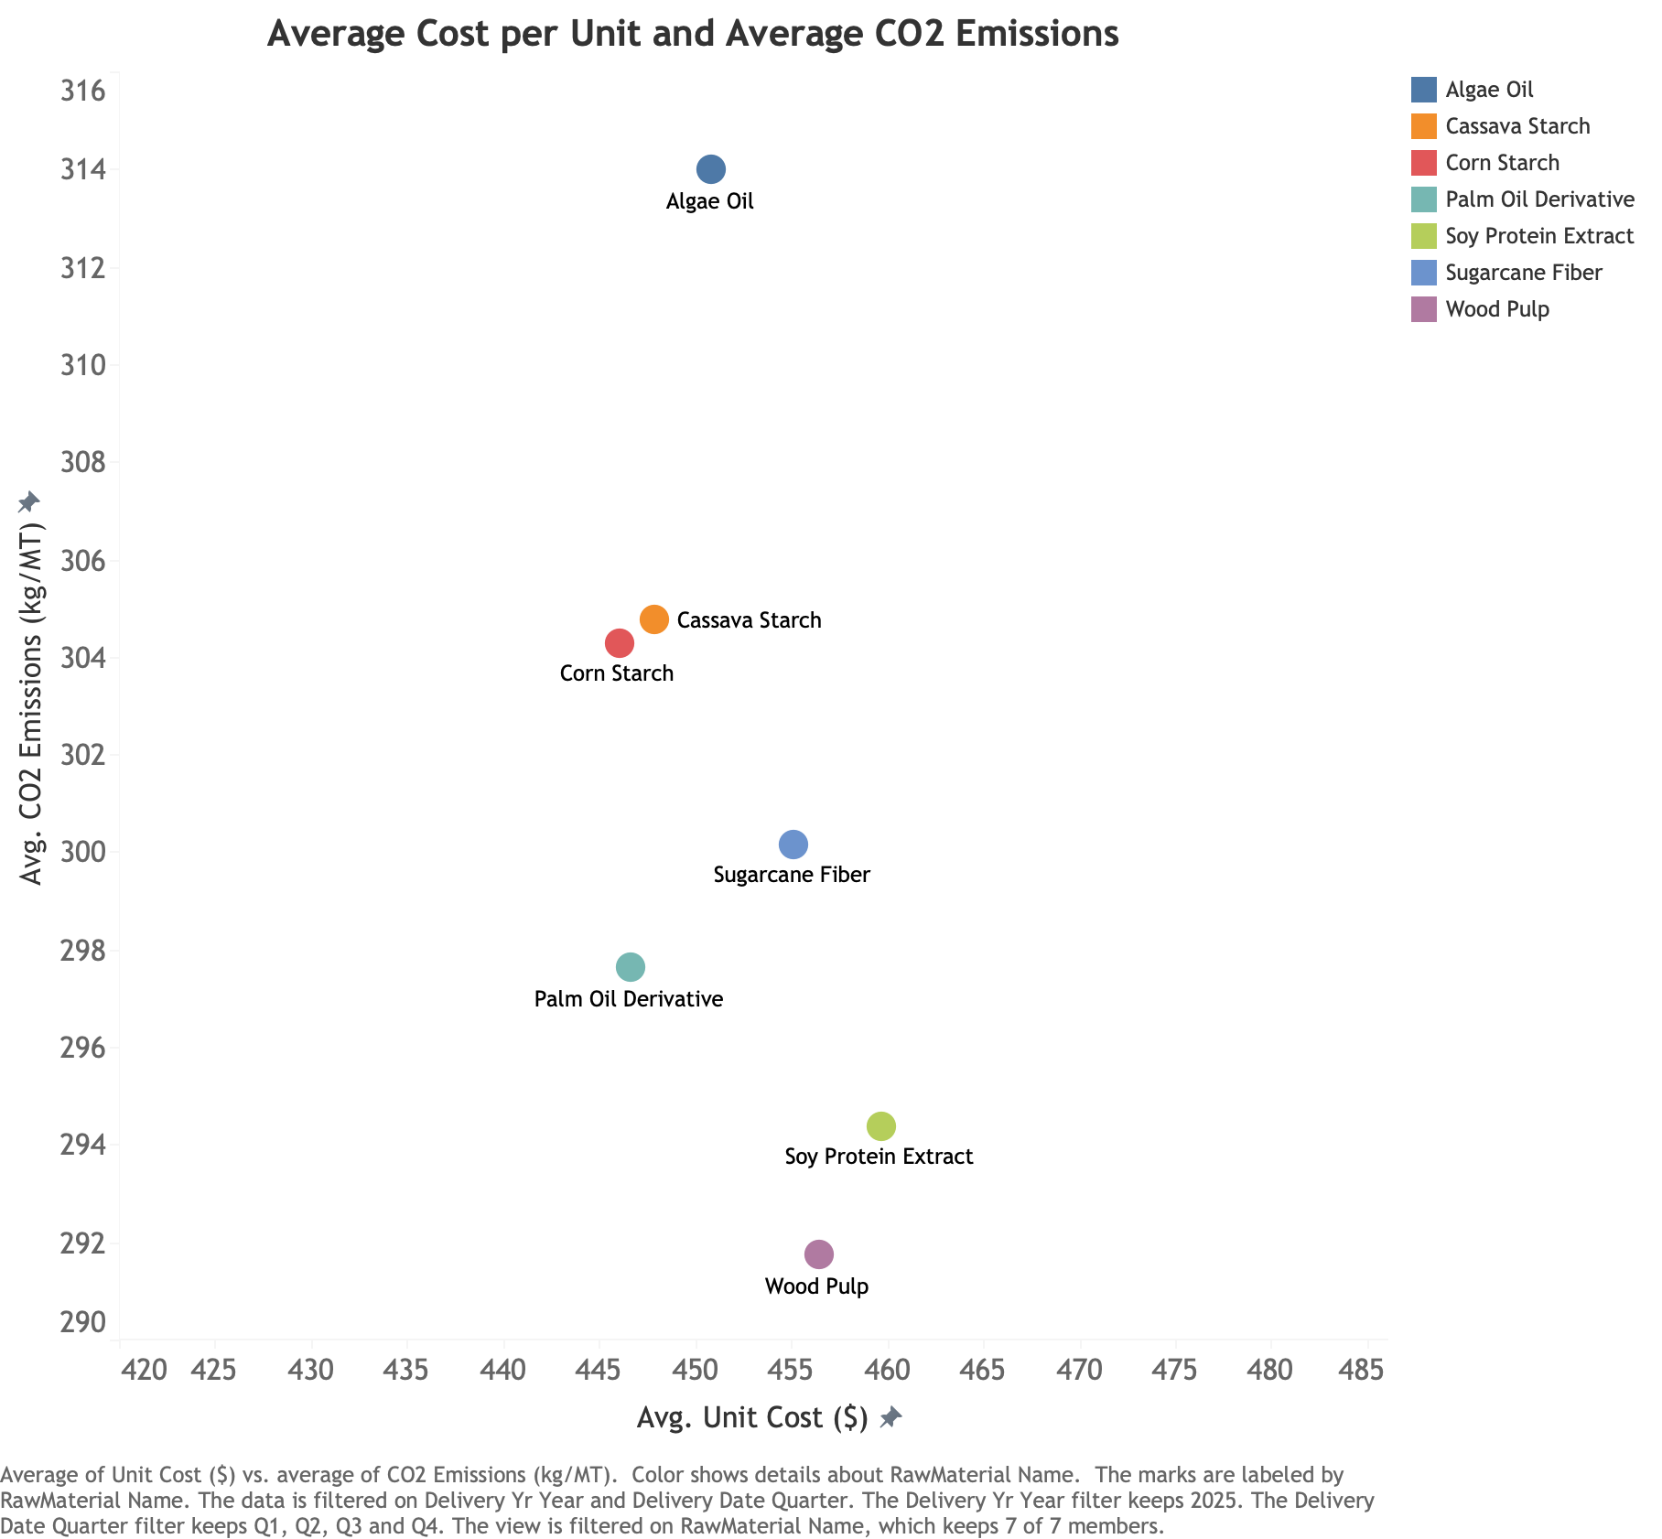
Figure 4. Project Launch Density (2025-2030)

Among five manufacturing plants, Brazil and Germany show the highest production efficiency, especially for Industrial Lubricants, Automotive Solutions, and Packaging Materials, while China and the USA report the lowest yield (Figure 5). Despite their strong output, Figure 6 shows that Brazil and Germany experience higher cost variances above standard expectations.
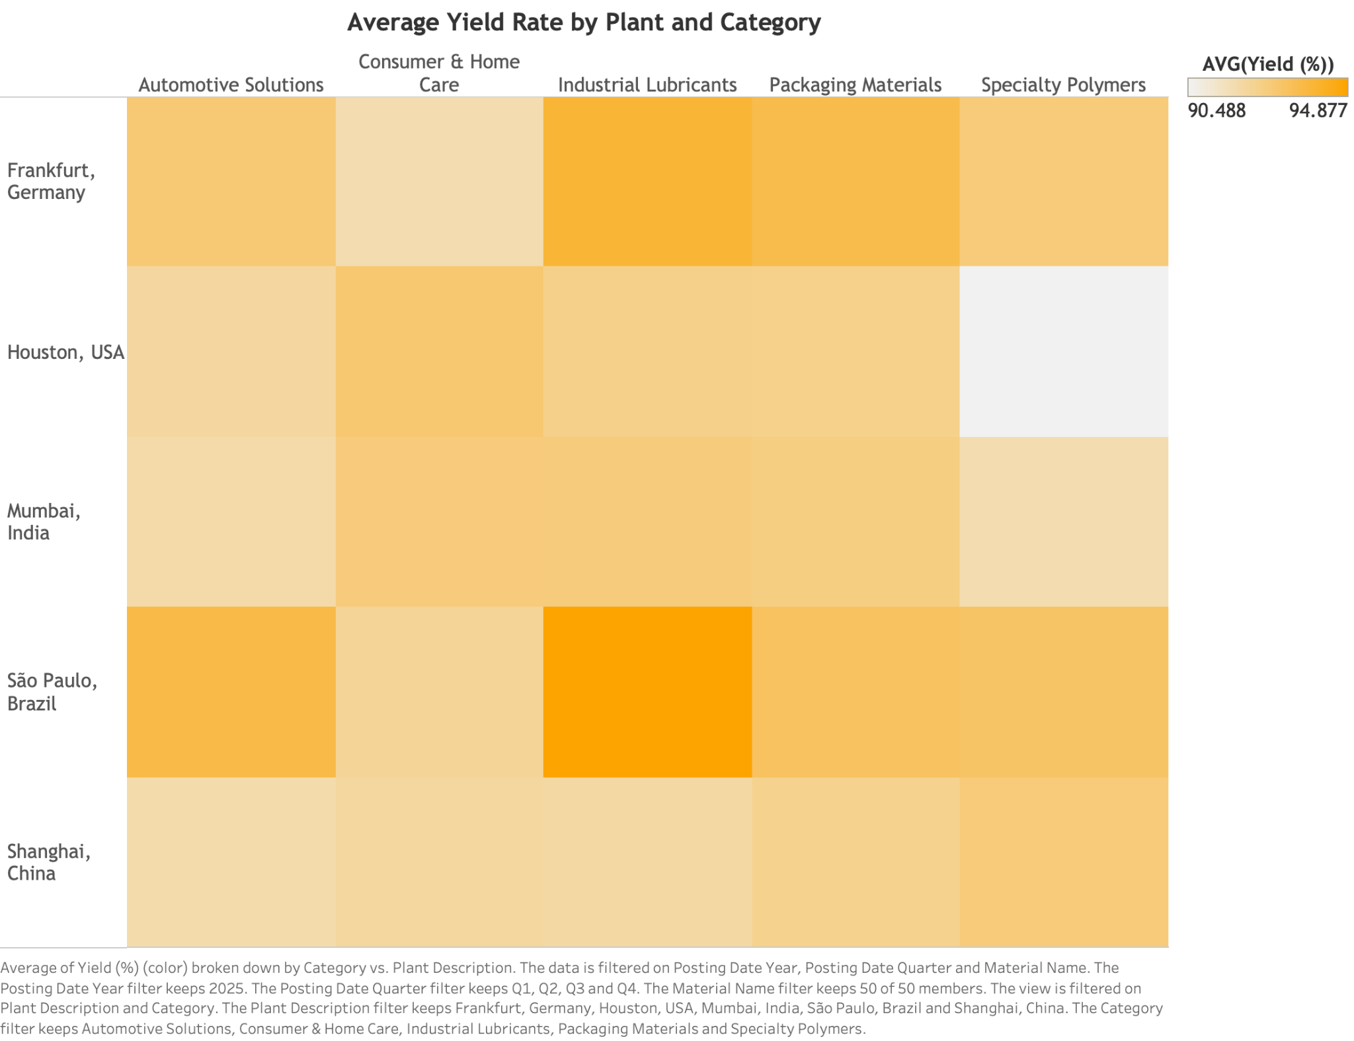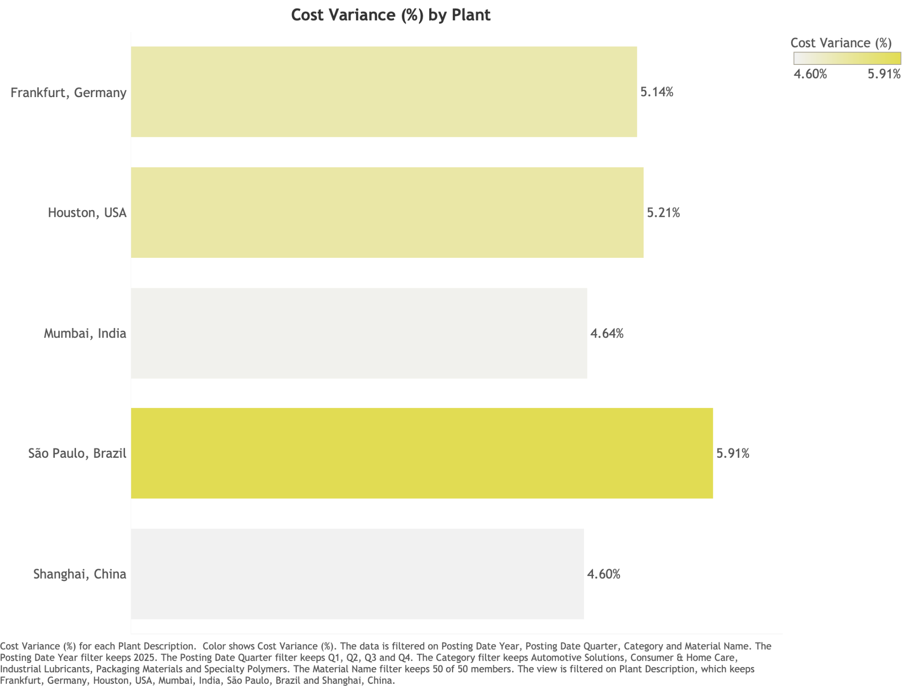
Figure 5. Project Launch Density (2025-2030) Figure 6. Project Launch Density (2025-2030)

SHORT-RUN STRATEGY (0-12 MONTHS)
Focus: immediate impact through supplier optimization and targeted sales efforts.
1. Optimize Supplier Mix
As immediate shifts are operationally challenging and we might avoid harming the partnership with current suppliers, we recommend gradually lowering 10% of order quantities from dominant suppliers. Using the $CO_{2 }$ avoided per $ of procurement shift metric:
$CO_{2 }avoided per \$= \frac{{Avg CO_{2 }emission per MT (kg)}_{current supplier}- {Avg CO_{2 }emission per MT (kg)}_{new supplier} }{{Avg unit cost (\$)}_{new supplier}- {Avg unit cost (\$)}_{current supplier}}$
Sign of value | Meaning
Large positive | Higher cost but lower-$CO_{2 }$supplier → pay more but get higher emissions
Small positive (~ 0-2) | Slightly higher cost for small emission gain → low priority
Negative and new unit cost < current unit cost | Cheaper and cleaner supplier → best case
Negative and new unit cost > current unit cost | Costlier and dirtier → avoid

Applying this model, a 10% reallocation of orders from dominant suppliers can yield measurable cost savings and emissions reduction (assuming consistent 2026 demand based on 2025 values). Please note that not all raw material needs this change, as results show that changing to other suppliers for that material might yield a higher cost.

Raw Material | Current Dominant Supplier → Alternative Supplier (10% Shift) | ΔCost Saved | CO2 Avoided (Tons)
Cassava Starch | AgroSource Intl. → EcoMaterials Co. | $47,439 | 117,089
Cassava Starch | SustainSource Inc. → NaturInput GmbH | $37,861 | 72,425
Corn Starch | BioFeedstock Ltd. → EcoMaterials Co. | $19,272 | 177,080
Corn Starch | NaturInput GmbH → EcoMaterials Co. | $26,935 | 53,921
Palm | AgroSource Intl. → EcoMaterials Co. | $8,873 | 64,355
Palm | NaturInput GmbH→ PalmEco Corp | $34,216 | 50,479
Soy Protein | GreenFibre BV → BioFeedstock Ltd. | $19,190 | 27,998
Soy Protein | PalmEco Corp → SustainSource Inc. | $42,629 | 68,342
Wood Pulp | PalmEco Corp→ EcoMaterials Co. | $21,263 | 79,690
Detailed calculation can be accessed in this sheet.
Even modest 10% reallocations could significantly cut emissions by 710,000 tons while saving around $257,000 in procurement costs within one year.
2. Refocus Sales Efforts on Key Categories
- Industrial Lubricants & Automotive Solutions: prioritize late-stage opportunities that have a higher probability.
- Consumer & Home Care: refine value messaging to improve low win-rate conversion

LONG-RUN STRATEGY (1-3 YEARS)
Focus: align profitability and sustainability at the structural level
1. Supply Diversification and R&D Acceleration
Given the limited information on plant-level sourcing, we don’t know if there are also logistics inefficiencies (e.g., raw materials are transported from India to the USA when there is a plant in India). If confirmed, the company should source materials closer to production plants to reduce logistics costs and emissions. Additionally, invest in Specialty Polymers and Automotive Solutions to innovate more cost-efficient, high-margin products.
2. Green Procurement KPIs
The $CO_{2 }$avoided per $ of procurement shift metric is only useful for immediate change, but for long-term planning, GreenFuture BioChem should adopt sustainable KPIs into its procurement evaluation:
- $CO_{2 }$per $1M purchased
- Supplier Sustainable Index (SSI)—weighted by unit cost score, emissions score, and on-time delivery score (detailed calculation).
To quantify supplier performance, SSI was constructed based on three dimensions: cost efficiency, carbon intensity, and delivery reliability. Each dimension was normalized to a 0–100 scale and weighted at 40% for cost, 40% for emission, and 20% for delivery, reflecting GreenFuture BioChem’s strategic balance between profitability and sustainability. The heatmap below visualizes SSI performance across raw materials (e.g., the greener the higher the index). Each raw material should prioritize the top two greenest suppliers to advance both profitability and sustainability.
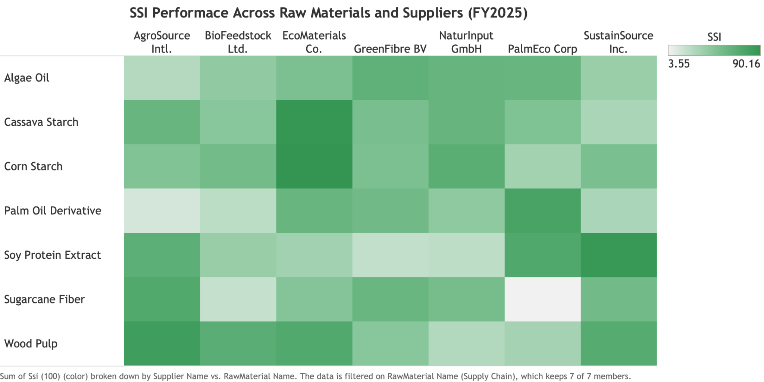
Figure 7. Project Launch Density (2025-2030)

REAL-TIME TRACKING DASHBOARDS
We also offer 3 data-driven and centralized dashboards on Manufacturing, Sales, and Supply Chain that should be deployed to monitor performance and sustainability KPIs in real time more effectively.

CONCLUSION
In the short run, GreenFuture BioChem should prioritize supplier optimization, except for Algae Oil and Sugarcane Fiber, while refining sales pitching on Consumer & Home Care to drive more profitability and cut $CO_{2 }$emissions. In the long run, the company should invest in R&D innovation on potential categories and reallocate its supplier network to decouple profitability from carbon intensity and achieve sustainable and data-driven growth.

DISCLAIMER

ASSUMPTIONS
- Win Rate
We calculated the win rate based on the total number of sales opportunities closed by month/year and the total number of won deals. As some opportunities were closed but not marked as “Closed-Lost”, we assumed those cases were already closed.
- Order Quantity of Raw Materials
To simplify our short-term procurement strategy, we assumed that demand for raw materials would be the same for 2026.
- $CO_{2 }$Emissions
As in the Supply Chain Procurement dataset, there is no direct explanation of which source these $CO_{2 }$emissions came from, either through transportation or through producing those raw materials from the suppliers before sourcing them to FutureGreen’s manufacturing plants.

AI USAGE
We acknowledge the use of AI during this case to help us better understand how companies apply metrics to track their procurement. We also seek help in making initial assumptions on which raw materials are used for specific brands or products, but when looking for online sources, there are many applications of those materials across the five markets. Therefore, we decided not to make it granular, which might skew our results.

CALCULATION SHEETS
- Revenue, Profit, Margin & Win Rate: Profit YTD 2025 Tab
- $CO_{2 }$Emissions Avoided
- SSI

